Primary Interventions

Quality Teaching Framework
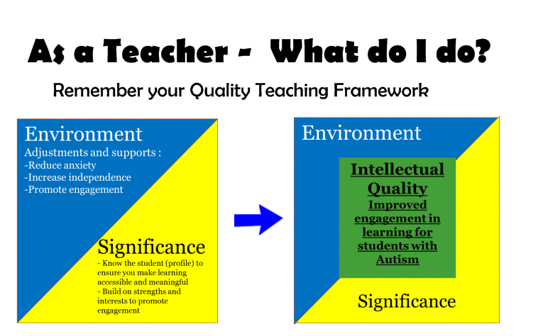
Whole School Approach
The model proposed by Lewis and Sugai (1999) provides the basis for the whole school system which many schools use. The basic principles are:
- Builds systems that make it easier to teach;
- Create environments that encourage (rather than discourage) pro-social behaviour;
- Teach all students what is expected;
- Provide a continuum of behaviour and learning support to students who need more support to be successful.
School-wide strategies should include:
- Statement of purpose;
- Clearly defined expected behaviours (rules of expectations);
- Procedures for encouraging expected behaviours;
- Procedures for discouraging problem behaviours;
- Procedures for record-keeping and decision.

Teacher Professional Learning
Research demonstrates that one of the most significant contributors to educational outcomes in the school environment is teachers. Quality professional learning for teachers and support staff is vital for ensuring that schools are able to meet the needs of their students. It must extend the knowledge and skills of teachers to plan and make adjustments for students in collaboration with students and their parents.
- For professional learning strategies/resources and courses go to the Professional Learning and Leadership Development Directorate: http://www.det.nsw.edu.au/proflearn
- Also look at online training for special educational needs at: http://www.inclusiononline-aus.net/index.asp
- Browse professional learning available course at MyPl@Edu
- Positive Partnerships courses provide current training to support teachers and parents of students on the Autism spectrum. Go to: http://www.autismtraining.com.au/public/index/cfm
- Non Violent Crisis Intervention (NCI) training is extensively used across NSW schools and supports the school-wide positive behaviour approach. Go MyPL@Edu to search for current courses in your area.

Classroom Management
At the risk of stating the obvious, classroom practices must be consistent with school-wide practices, particularly as regards positive behaviour support. The same principles apply:
- Rules explicit;
- Students/teachers aware of rights and responsibilities;
- Consistent language of choice used across school;
- Consistent consequences;
- Explicit teaching of pro-social behaviours.
Never be worried about asking a colleague for help. There are many sources of information/resources/help available.
In your school: The Executive, The School Counsellor, the Learning and Support Teacher.
On the intranet:
https://detwww.det.nsw.edu.au/lists/directoratesaz/proflearn/ftteacher/prespace.html Look at the “First Time Teacher Toolkit”
On the internet:
http://www.sparklebox.co.uk/class-management/
http://www.teachingideas.co.uk/more/management/contents.htm
http://www.theteacherscorner.net/classroom-management/
http://www.tes.co.ul/behaviour-classroom-management-whole-school-teaching-resources/
And the list goes on…

Toolkit
Download the NSWDEC DDA click on the link below:
http://www.comlaw.gov.au/Details/C2009C00402
Student Profiling:
https://sr-eses-resources.wikispaces.com/file/view/Developing%20Student%20Profiles%20Workshop%20FINAL.pdf/378491796/Developing%20Student%20Profiles%20Workshop%20FINAL.pdf
Developing Learning Profiles:
http://sr-eses-resources.wikispaces.com/file/view/Conference%203%20Unhidden%20version%20ASD.pdf/422351318/Conference%203%Unhidden%20version%20ASD.pdf
Developing Effective Interventions with FBA:
https://sr-esesresources.wikispaces.com/file/view/Conference%2DMarch%2018%2OUnderstanding%20and%20Assessing%20behaviour%20Lynn.pdf/427879364/Conference%20March%2018%20Understanding%20and%20Assessing%20behavour%20Lynn.pdf
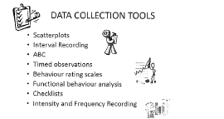

Follow link to: Understanding and Assessing Behaviour Powerpoint by Lynn Edwards to find additional information.
http://sr-eses-resources.wikispaces.com/file/view/Conference%March%2018%20Understanding%20and%20Assessing%20behaviour%20Lynn.pdf/427879364/Conference%20March%2018%20Understanding%20and%20Assessing%20behaviour%20Lynn.pdf
Examples of Scatterplot Diagrams:
http://www.specialconnections.ku.edu/-specconn/page/behavior/fba/pdf/examplescatter.pdf
http://www.specialconnections.ku.edu/?g=behavior_plans/functional_behaviour_assessment/teacher_tools/scatter_plot
Examples of A-B-C Checklist:
http://www.specialconnections.ku.edu/~specconn/page/behavior/fba/pdf/blankabcchart.pdf
Examples of Interval Recording Proforma:
http://www.behaviourbabe.com/datasheets.htm

http://www.cheri.com.au/documents/wsrhebershamcheri2.pdf
www.det.nsw.edu.au/every-student-every-school

